The Media Portrayal of Serena Williams and Rafael Nadal
Ashley Bastock
John Carroll University
Dr. Beadle
CO 322-51
30 April 2012

ABSTRACT
Serena Williams and Rafael Nadal are two of the most dominant players in the tennis world today, and are both focal points in the worldwide media. Using various types of media, including: Twitter, Facebook, official websites, articles, pictures, and endorsement deals, this study aims to show the different ways these two athletes are interpreted and portrayed in the media. Through an examination of these different types of media, it is obvious that both Williams and Nadal are portrayed as dominant athletes; however, at times, Williams is sexualized as a result of her gender and celebrity in America. While this sexualization occurs, it is obvious that Williams plays a major role in condoning this because it helps her celebrity image.

Serena Williams and Rafael Nadal are arguably two of the best and well-known tennis players in the world. There are many similarities between the two, like the support of millions of fans, media attention, and interesting personas and background stories. Williams has become known as the tough woman from Compton, who has been in a longstanding rivalry with older sister Venus. Nadal has become the pride of Spain, and was a key player in one of the most famous tennis matches of all-time when he played Roger Federer at Wimbledon in 2008. While their achievements as tennis players are extraordinary, this study truly seeks to understand how they are portrayed, and how they portray themselves in the media. Overall, especially in America, it is obvious that Serena Williams has a greater amount of exposure and celebrity, and it is because of this exposure that she presents herself in different ways. Serena Williams is portrayed in a very sexualized way, especially when compared to Nadal, who with only a few exceptions is portrayed as an athlete rather than a sex symbol; however, it appears that this portrayal of Williams is one that she both creates herself and thrives under.
Twitter Account Portrayals and Interactions of Williams and Nadal
Serena Williams is incredibly active in the world of social media. When first logging onto her twitter page, (www.twitter.com/serenawilliams), the background of her profile features a collage of very glamorous pictures of Williams wearing tight fitting, revealing clothing. In every picture, her hair is down and styled, and she wears very expensive and elaborate jewelry. All of the pictures are taken from the chest up, and her face is the focus of most of them, taking up roughly 70 percent of each picture. In her profile picture, which has the most focus and visibility, Williams is wearing a leather jacket, pink lipstick, and has straight hair. Her body is at an angle to the camera and this shot is also from her chest up. Next is Williams’ personal description, which reads, “Living, loving, and working to help you” (Williams, 2012b). It is very odd that a world-class athlete lists nothing saying that she is in fact, an athlete. Yes, Serena Williams is a very well known public figure, but the first thing she identifies herself as should be a tennis player-- there is no indication of this so far. When it comes to the messages Williams puts out to fans, the same phenomenon occurs. Her tweets are rarely about tennis matches or her tennis career. On April 6th, she even tweeted that she “prefers heels to tennis shoes” (Williams, 2012b). She also spends a great deal of time responding to fans, and even has “Serena Friday” where fans can ask her questions that she promises to answer (Williams, 2012b). She also spends time on product promotions, tweeting about her fashion line selling on HSN and promoting Nike products. On March 29th she tweeted to her 2.5 million followers, talking about her new Nike shoes: “Have you ever seen cuter tennis shoes? Can’t wait to wear them!” (Williams, 2012b). Williams has also posted 29 pictures on her account, and most are close-ups of her face looking longingly at the camera. She has also posted pictures of herself in bikinis. There was one occasion where she posted pictures of her newest shoes and another occasion where she posted a picture of her taped ankles after a match. It is very rare that Serena Williams discusses her tennis career or appears as a tennis player in her photographs. This trend continues onto her Facebook page, and to an extent on her personal website. Where Williams is extremely active with Twitter, Nadal is slightly more reserved and sends an arguably different message.
Rafael Nadal portrays himself as an athlete via Twitter, and this is extremely obvious and deliberate. The background of his Twitter page (www.twitter.com/rafaelnadal) features a picture of Nadal wearing all black tennis gear, holding a racket, and celebrating with a very intense look of domination on his face. He is photographed from the side, but the picture is still a very prominent one. For his profile picture, there is an action shot of Nadal playing during a match on a clay court. This is once again significant because he is definitely sending only one message with this picture— he is a tennis player. This continues when he goes on to describe himself in his description, simply saying “Tennis player” (Nadal, 2012b). There is no mention of anything except tennis and his career. When it comes to interactions, he does not really attempt to talk to his fans like Williams. The only people he talks to are other athletes such as Bubba Watson, Ricky Rubio and Christiano Rinaldo. He does not spend a lot of time on Twitter, especially when compared to Serena. Nadal has posted 30 photos of himself on his account, and the majority of them are of him playing tennis, arriving to play tennis, or just finishing playing tennis. There are several where he is with friends and dressed nicely, but the majority still depicts him as a world-class athlete.
Serena Williams and Rafael Nadal have very different personalities and images based on their Twitter pages. Serena presents herself as a very glamorous figure and definitely appears sexualized. She also spends a lot of time interacting with her fans and voicing her opinions on other issues. Nadal comes off as more of an athlete that keeps to himself, and only really appears interested in his tennis career, rather than maintaining a celebrity image.
Facebook and Official Website Portrayals of Williams and Nadal
Serena Williams’ glamorous image is still perpetuated as much, if not more than, her tennis-playing image on her Facebook page (www.facebook.com/serenawilliams). There are only three of her featured pictures that show Williams playing tennis, and her current featured picture is a glamour shot. Williams is wearing minimum clothing, where only her bust to the very top of her legs is covered. You cannot see all of her body, which causes objectification. Her hair is curled, her makeup is perfect, and her jewelry is very elaborate; however, her description is more accurate for her actual career. It describes how she has won “23 career Grand Slams which include 11 singles titles, 2 mixed doubles and 10 in women’s doubles in order to become one the game's greatest all-time players” (Williams, 2012a). The whole section describes her career and how she rose to become a successful athlete. This section also links to her official website where Williams once again is portrayed in mixed ways. The homepage to the website features a pink and black design, and a very large picture of Serena who is wearing a low-cut black top, with absolutely no tennis or athletic apparel in view. Her website does have pages with videos and pictures of Serena playing tennis, and shows much more dealing with her athletic abilities than her Facebook page or Twitter account (Serena Williams Online, 2012). While Williams’ Facebook page and official websites send mixed messages, the message Nadal sends with his pages is obvious.
Rafael Nadal’s Facebook page (www.facebook.com/Nadal) is also very similar to his Twitter page. Nadal’s two featured pictures both show him playing tennis. The most prominent picture is the same picture used for his Twitter account of him playing on a clay court during a match. The other featured image is a photo of him shown from the chest up, with an intense look on his face, showing him in the middle of a match. Also, most of his photo albums are devoted to specific matches he has played in, such as the 2011 Wimbledon Quarter final and Semifinal matches. (Nadal, 2012a). When he uses his Facebook, his posts are almost identical to those that are on Twitter. He updates fans on how matches went or where he is going. It does not appear that he spends time trying to promote products or creating an image for himself. It is quite obvious that Nadal is not trying to perpetuate any celebrity image through his Facebook page. His description simply says “Athlete” with a link to his official website (www.rafaelnadal.com). His website is currently down; however, the page that comes up still portrays Nadal as a world-class tennis player. On the page is the same picture of him used as his Twitter background, and under this it says “Spirit of Improvement On and Off the Court (We are working for a better web. Sorry for the inconvenience)” (Rafael Nadal Online, 2012). Once again, this displays Nadal’s competitive nature and athletic abilities. This appears to be the image that is perpetuated throughout the media so far.
Serena Williams discusses her tennis career on her Facebook page, but she still presents a sexualized, glamorous, and feminine image. Nadal once again appears to not perpetuate any image except his athletic one. William’s official website definitely has more information about her tennis playing career than anything else, but she is still sending a mixed and sexualized message, where Nadal is sending a very consistent one.
News Articles Written About Williams and Nadal
When articles are written about Serena Williams as a tennis player, they hardly seem to concentrate on her gender. Words and phrases like dominant, powerful, and best in the world are used in multiple articles to describe her performance as an athlete. Simon Reed, a Eurosport expert for Yahoo! Sports, says that Serena Williams does “not just beat her opponents, but butchers them in quite ruthless and emphatic fashion. . . Serena has, without any doubt, been the best player in the world for the last decade and no one has come close to matching her” (Reed, 2012, para. 4). Throughout the article he uses words like powerful, tough, aggressive, and unstoppable in describing her as an athlete. Another recent article from ESPN describing Williams’ victory at the Family Circle Cup talks about her in similar fashion; however, it also talks about how she is a very busy and diverse woman. They refer to her performance as “strong, dominant and powerful,” but the first thing they describe is her busy life, saying the athlete also is dealing with “college classes, a re-launch of her clothing line, and a possible move to Paris (Associated Press, 2012c, para. 1). The article also mentions how she is only behind her older sister Venus by three championships when it comes to active players with the most wins. This is not surprising, because it seems like the press tends to not talk about one Williams sister, but both; in fact, two other articles on ESPN.com, featured headlines saying: “Serena Advances, Venus Eliminated,” and “Venus, Serena Williams Both Advance.” The Williams sisters are a compelling story since they are siblings who both excel at the same sport, and oftentimes this creates a rivalry; however, in a USA Today article, Serena Williams is discussed alongside Rafael Nadal. Ellen Horrow describes Serena as dominant, which is obviously a common theme in the press and how they view Serena. What is perhaps most interesting about this particular article, however, is the fact that in an article that focuses on both Williams and Nadal, Williams is the headliner and is written about first (Horrow, 2012). It is obvious that this is because Williams is dominant regardless of her gender, and many male athletes and members of the press have taken note. In a recent AP article posted on ESPN.com, John Isner, who is “America’s top-ranked singles tennis player,” says that there is no one he would rather compete with in mixed doubles this summer than Serena Williams (Associated Press, 2012a, para. 2). In fact, since mixed doubles was announced for the 2012 Summer Olympics, Andy Roddick and the Bryan brothers have also expressed interest in playing with Williams. While research shows that the press tends to portray Serena as a dominant force in the game of tennis, she has dealt with some minor media backlash.
While everyone acknowledges that Serena Williams is dominant, the media also concentrates on her etiquette and fashion choices on the court. An article posted on ESPN states that Williams’ “on-court etiquette has been criticized, and rightfully so” (Ubha, 2012, para. 13). She has been known to lose her composure and start fights on the court, and the media has taken notice. She is often criticized for her competitive nature and at times is portrayed as un-sportsmanlike; however, Serena is more often criticized for her on the court attire than anything else. According to CNN, Both of the Williams sisters have been “setting, and sometimes destroying, trends with their extroverted dress sense” (Chandler, 2010 p. 1). Serena competes in designer dresses, like the turquois blue dress she wore at Roland Garros in 2009. At the 2004 U.S. Open, Serena Williams was questioned for wearing knee-high black boots, a denim-like mini-skirt, and a black low cut top that was also cropped at the stomach. Perhaps her biggest fashion faux pas came when she chose to wear a one-piece skin-tight black cat suit at the 2002 U.S. Open. The analysts and tennis purists do not always approve of these bizarre fashion choices, especially in a sport where white, black and blue are the traditional outfit colors of choice. Serena Williams “stands out by wearing bright colors, and is always adorned with expensive looking jewelry” (Chandler, 2010, p. 13). Serena does appear to dress in a very sexualized manner, especially when compared to her competitors. Williams has had both positive and negative press. While the coverage of Nadal seems pretty neutral, he is still portrayed as a rather dominant player, even in the face of adversity.
The articles written about Rafael Nadal tend to describe the strengths of his tennis game. Ravi Ubha of ESPN (2012) described all of the personal problems and injuries Nadal has gone through over the past few months, but then went on to say that he is “still the man to beat” (Ubha, 2012, para. 8). In an article written by Stephen Tignor of ESPN, Nadal’s recent injuries and on the court losses to rival Novak Djokovic are discussed; however, it goes on to describe how this season, their “rivalry on clay should be the most dramatic of all” (Tignor, 2012, para. 2). This is one of the first times a narrative-like approach is taken when discussing Nadal. Rather than portraying him as a dominant tennis player, the article shows that he has flaws and legitimate competition in the form of Djokovic. Jerome Pugmire of The Associated Press (2012) also describes this rivalry between Nadal and Djokovic in a recent article posted on Yahoo! Sports. He describes how “Djokovic handed Nadal his only two losses on clay last year . . . [but] Nadal is [still] the ultimate challenge on clay” (Pugmire, 2012, para. 3-4). It is obvious that Nadal is thought of as dominant in the press, and even though he is dealing with personal struggles, it does not appear that this is creating negative publicity. The media is only concentrating more on his rivalry with Djokovic. Even though they portray Nadal as dominant, everyone is waiting for him to fall.
Serena Williams is portrayed as a dominant athlete when it comes to her play on the court, and this view is consistent with all of the press she gets; however, this does not stop them from pointing out flaws with her appearance, and sometimes for her over-competitive nature. Nadal is also portrayed as one of the most dominant in his sport, but the press also likes to point out the adversity he is currently facing. The language used to describe these two athletes’ strengths is very similar, in the sense that news organizations tend to focus on their dominance in the tennis world regardless of their gender.
The Endorsement Deals and Advertising Portrayals and Photos of Williams and Nadal
Serena Williams has an almost endless list of endorsements, and she is portrayed in an endless amount of ways when selling these different products. In her magazine advertisements for Tampax, she is displayed on the tennis court as a tough player, battling against Mother Nature (Glamour Magazine, 2010). These ads clearly display the dominance that many sportswriters convey in articles about Williams. The Gatorade ad Williams did also shows pure intensity, with a black and white action shot and Williams mid swing (Marie Claire, 2010). While these print ads show Williams at her best as a tennis player, there are some ads that portray her as a highly sexualized figure. A new commercial for the video game Top Spin 4 features Williams in a black, leather, one-piece outfit that is extremely short and exposing her cleavage. During this ad, Williams is playing the latest tennis video game from PlayStation (Rebel Alliance Media, 2011). In Serena’s new O.P.I. Nail Polish campaign ads, she is featured from the waist up wearing a form fitting white dress. Her face is tilted slightly upwards so that her eyes are not looking directly into the camera, and the pictures of the nail polish colors appear where her legs should be seen (Marie Claire 2011). This creates an objectified image. Williams’ entire body is not shown, which makes her less human-like, and more object-like. Her body is not in a dominant pose, and instead is more passive with a gaze that is not looking directly in the camera. It is clear through advertisements, articles, and social media sites, that Serena Williams is portrayed in many different ways and is a very popular public figure. Williams is portrayed as both a sexual figure and a dominant athlete in her endorsement deals. To an extent, so is Nadal; however, the way he is sexualized is fundamentally different.
Rafael Nadal is sexualized in some ways when it comes to the ads he stars in; however, when he is sexualized he still appears to be in a dominant position. In his new campaign for Armani Underwear, Nadal looks more like a model than a tennis player. There are a lot of shots in this new commercial where the camera slowly pans up and down his shirtless body. The ad also depicts him on a beach where he is also shirtless the entire time (Fashion Illustrated, 2011). This is a sexualized portrayal of Nadal, however his sex appeal is dependent on his dominant masculinity, rather than passive vulnerability. An ad for Nike pro also shows Nadal’s sex appeal, having him sit shirtless in a locker room bouncing a tennis ball; however, when he puts on his Nike gear, the ad changes tones and then actually shows him playing tennis (Nadal, 2010). While this sexualization is minor, it is still obvious the dominance that Nadal carries with his image. In a commercial done for Kia, however, Nadal is depicted only as a strong tennis player. Kia uses Nadal’s intensity and accuracy in order to make their product look better (Kwon, 2008). The ad does not demean him, but places him in a positive light.
There are ads that depict Serena’s dominance, however, they almost always concentrate on using her sex appeal and glamorous image when it comes to selling products. Nadal is sexualized in his Armani ads, but he is still shown in a dominant way. The sexualization of the two athletes is a double standard; because, when Williams is sexualized she is no longer shown as a dominant athlete, but rather as a vulnerable and passive woman.
Conclusions About Media Portrayal of Williams and Nadal
Serena Williams is portrayed in a sexualized way through her personal websites and endorsements, and yet for the most part is portrayed in a dominant light when it comes to articles about her playing career. This sexualized image then, is not only one that Serena accepts, but one that she helps to perpetuate. The reality is, Serena Williams is not only an athlete-- she is a celebrity. The majority of women who are celebrities in Hollywood are sexualized and airbrushed beyond recognition. Williams grew up in a culture where she would have been bombarded with these images like every other young girl. Successful women are demeaned through ad campaigns to sell products. Powerful women are made to be vulnerable in order to be kept in their place. Williams is no different. She is portrayed in sexualized and demeaning ways at times, and without a doubt this is because she is a woman. With the amount of sexualized images women are bombarded with, it is no wonder Williams at times appears to be more concerned with how she looks rather than with portraying herself as an athlete. She not only has to worry about her playing career, but her celebrity image; therefore, she must adhere to the standards that celebrities set before her. Unfortunately, this perpetuates the message that to be successful and influential a woman must look a certain way. It is obvious that her accomplishments are endless on the tennis court, and they should be enough to validate Williams’ success; however, her sexualized image is still a part of who she is as a celebrity. Nadal does not carry this weight of celebrity in the U.S. as much as Williams, because he is a Spanish native and far more popular overseas; therefore, in America his image is very straightforward and to the point. Nadal at times can be sexualized, but he is still made out to be dominant. When it comes to the media portrayal of Nadal, he is always viewed as a dominant and masculine athlete, which is in stark contrast to Williams.
When it comes to their playing careers, however, Nadal and Williams are described using the same language and the press portrays them both as dominant athletes. Williams is not portrayed in a different light because of her gender. While this is positive, the fact is Williams’ sexualized image still exists, and at times it is obviously only because she is a woman and is using her sexuality to sell a product or cater to her fans. Overall, the media portrayal of Williams and Nadal is different, and regardless of whether or not Williams perpetuates these differences, they still exist and turn her into a more vulnerable figure.

Works Cited
Associated Press. (2012a, April 17). John isner lobbies serena williams. Retrieved from
http://espn.go.com/olympics/story/_/id/7824848/john-isner-wants-pair-serena-williams-
london-olympics-mixed-doubles
Associated Press. (2012b, April 6). Serena advances, venus eliminated. Retrieved from
http://espn.go.com/tennis/story/_/id/7783411/serena-williams-advances-venus-williams-
loses-samantha-stosur-family-circle-cup
Associated Press. (2012c, April 8). Serena williams dominant in title win. Retrieved from
http://espn.go.com/tennis/story/_/id/7789243/serena-williams-wins-family-circle-cup-title
Associated Press. (2012d, April 5). Venus, serena williams both advance. Retrieved from
http://espn.go.com/tennis/story/_/id/7779717/venus-williams-serena-williams-advance-
reach-family-circle-cup-quarterfinals
Chandler, H. (2010, May 26). The highs and lows of the williams' wardrobe. Retrieved from
http://www.cnn.com/2010/SPORT/tennis/05/25/tennis.venus.serena.fashion/index.html
Fashion Illustrated. (2011). Rafael nadal armani campaign [Web]. Retrieved from
http://www.youtube.com/watch?v=DiR0kToJ2p4
Glamour Magazine. Serena williams tampax ads. (2010). [Print Photo]. Retrieved from
http://www.celebrityendorsementads.com/celebrity-endorsements/celebrities/serena-
williams/
Horrow, E. J. (2012, April 11). Serena, isner shine on clay as 'nadal season' begins. USA Today,
Retrieved from http://www.usatoday.com/sports/tennis/story/2012-04-09/weekly-net-
post-serena-isner-nadal-titanic

Kwon, A. (Producer) (2008). Rafael nadal- kia [Web]. Retrieved from
http://www.youtube.com/watch?v=9GQQlVP5rcI
Marie Claire. Serena williams gatorade. (2010). [Print Photo]. Retrieved from
http://www.celebrityendorsementads.com/celebrity-endorsements/celebrities/serena-
williams/
Marie Claire. Serena williams O.P.I grand slam. (2011). [Print Photo]. Retrieved from
http://www.celebrityendorsementads.com/celebrity-endorsements/celebrities/serena-
williams/
Nadal, R. (Performer) (2010). Nike pro [Web]. Retrieved from
http://www.youtube.com/watch?v=NyQnZGQfWNA
Nadal, R. (2012a). Rafael Nadal [Facebook Account]. Retrieved from
http://www.facebook.com/Nadal
Nadal, R. (2012b). Rafael Nadal [Twitter Account]. Retrieved from
http://www.twitter.com/rafaelnadal
Pugmire, J. (2012, April 15). Djokovic aims to end nadal's reign in monte carlo. Retrieved from
http://sports.yahoo.com/news/djokovic-aims-end-nadals-reign-184013411--ten.html
Rafael Nadal Online. (2012, March 15). Retrieved from
http://www.rafaelnadal.com
Rebel Alliance Media. (Designer) (2011). Serena williams top spin 4 [Web]. Retrieved from
http://www.youtube.com/watch?v=waYIBkGUSjE
Reed, S. (2012, April 11). Unstoppable serena still world's best. Retrieved from http://uk.eurosport.yahoo.com/blogs/simon-reed/unstoppable-serena-still-world-best.html

Serena Williams Online. (2012, March 26). Retrieved from
http://www.serenawilliams.com ("Serena Williams Online," 2012)
Tignor, S. (2012, April 4). Pressure building for djokovic, nadal. Retrieved from
http://espn.go.com/tennis/blog/_/name/tennis/id/7775691/tennis-pressure-building-novak-
djokovic-rafael-nadal
Ubha, R. (2012, April 11). The return of the real rafa?. Retrieved from
http://espn.go.com/tennis/story/_/id/7797150/tennis-return-real-rafael-nadal
Williams, S. (2012a). Serena Williams [Facebook Account]. Retrieved from
http://www.facebook.com/SerenaWilliams
Williams, S. (2012b). Serena Williams [Twitter Account]. Retrieved from
http://www.twitter.com/serenawilliams

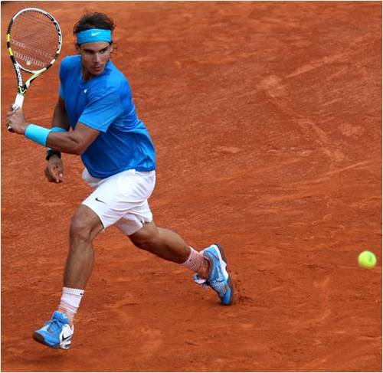
(Williams, [Twitter Account], 2012) (Nadal, [Twitter & Facebook Accounts], 2012)

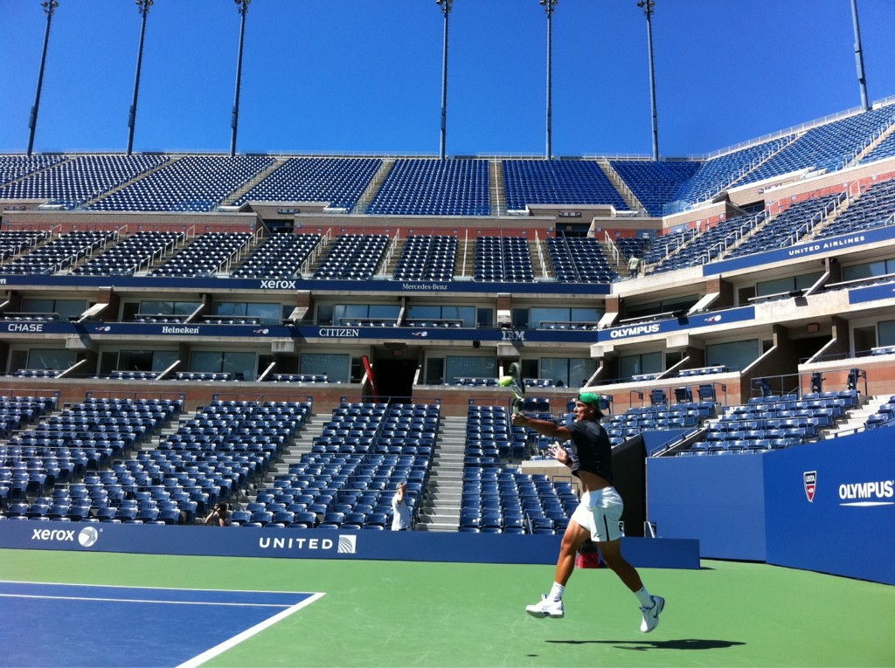
(Williams, [Facebook Account], 2012) (Nadal, [Twitter Account], 2012)
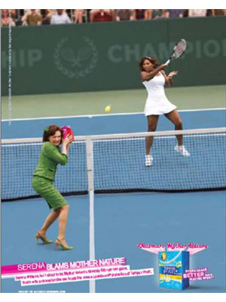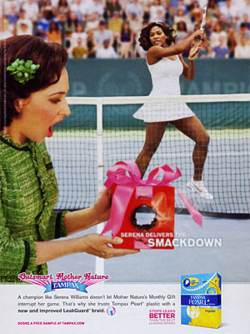
(Glamour, 2010) (Glamour, 2010) (Glamour, 2010)
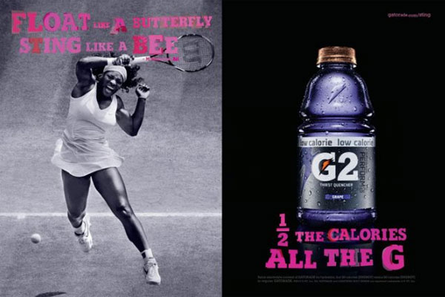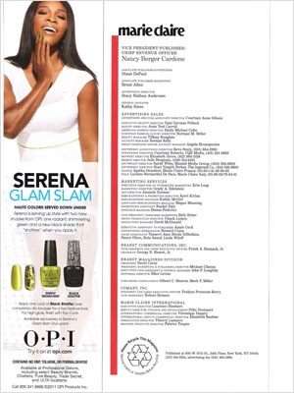
(Marie Claire, 2010) (Marie Claire, 2011)
(Fashion Illustrated, 2011)

